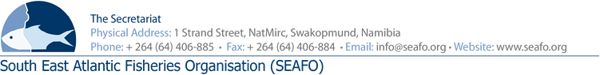
PROVISIONAL AGENDA FOR THE 11TH MEETING OF THE STANDING COMMITTEE ON ADMINISTRATION & FINANCE (SCAF) - 2019
Item | Agenda Item | Working Document
1 | Opening of meeting by Chairperson
2 | Appointment of rapporteur
3 | Adoption of Agenda and meeting arrangements | DOC/SCAF/00/2019  DOC/SCAF/01/2019  DOC/SCAF/02/2019
4 | Introduction of Delegations
5 | Presentation of the 2018 Audit Report | DOC/SCAF/03/2019  DOC/SCAF/04/2019
6 | Presentation of the Executive Secretary’s Report on Administration & Finance | DOC/SCAF/05/2019
7 | Staff Regulations changes to comply with Namibian Labour Law | DOC/SCAF/06/2019
8 | Approval of 2020 Provisional & 2021 forecast Budget | DOC/SCAF/07/2019  DOC/SCAF/08/2019
9 | Contribution by Contracting Parties | DOC/SCAF/09/2019
10 | Election of Chair & Vice-chair
11 | Any other matters
12 | Venue & date of next meeting
13 | Adoption of the 2019 Standing Committee on Admin & Finance Report
14 | Closure of meeting

CHAIRPERSON: Mr. Hideki Moronuki (Japan 2018-2019) VENUE: Strand Hotel, Swakopmund
VICE-CHAIR: To be confirmed (Korea 2018-2019) DATE: 27 November 2019

Circulation Date: 27 October 2019

